Task 5- Monitoring & Logging

Monitoring Metrics of server:

Install Prometheus and Grafana:

- Prometheus and Grafana were installed on an Ubuntu server using the traditional installation method.

The following screenshot shows both services running successfully:

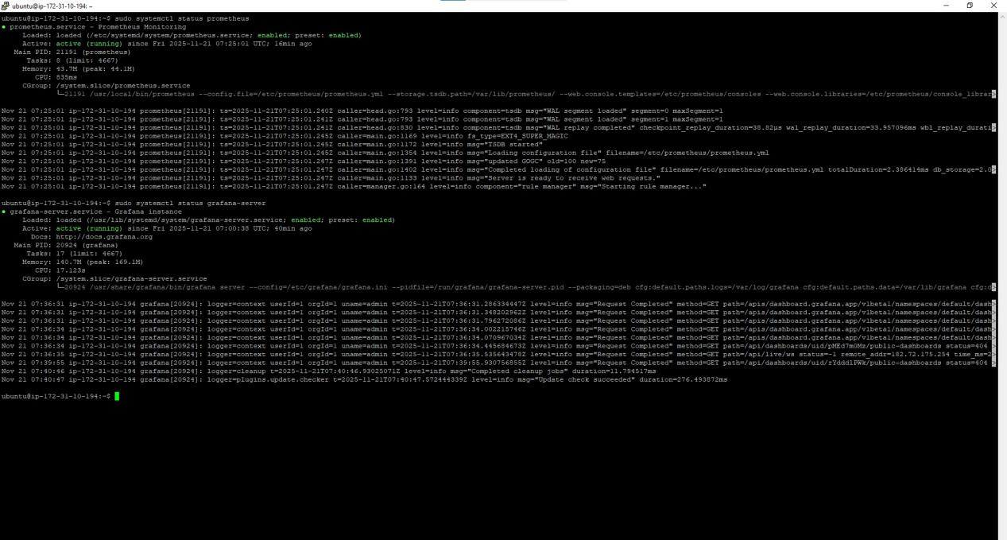

Access the prometheus and grafana the browser using Ip address with port:

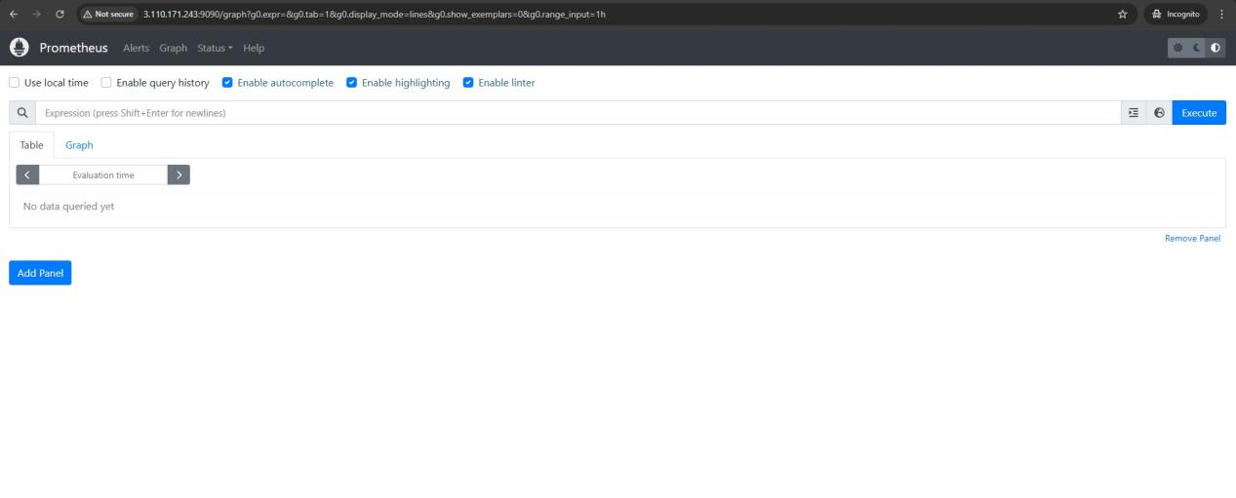

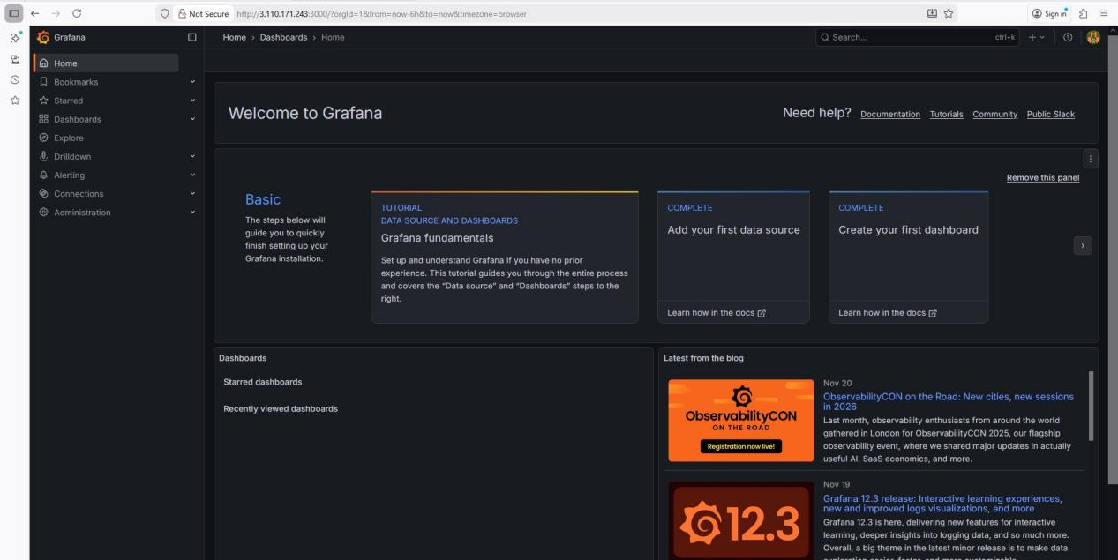

Install Node Exporter:

- Node Exporter was installed on the server to collect system metrics, which can be scraped by Prometheus for monitoring purposes.

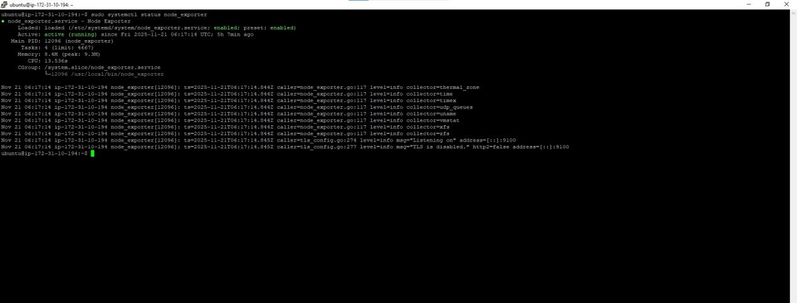

Add Prometheus as a Data Source in Grafana

- Navigate to Configuration Data Sources Add data source.
- Select Prometheus.
- In the URL field, enter the Prometheus server address, e.g., http://<IP_ADDRESS>:9090.
- Click save & Test to verify the connection.

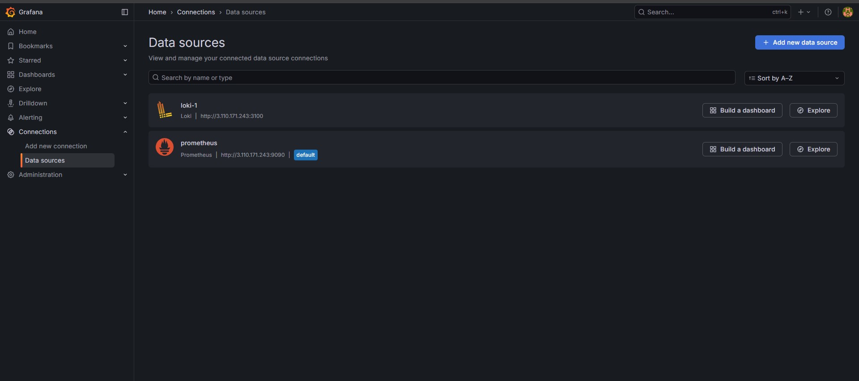

Configure Grafana Dashboard for Node Exporter:

- Open Grafana and navigate to Create Import. Enter the dashboard ID: 1860.
- Select the Prometheus data source you added earlier.
- Click Import to load the dashboard.
- The dashboard now displays server performance metrics collected by Node Exporter.
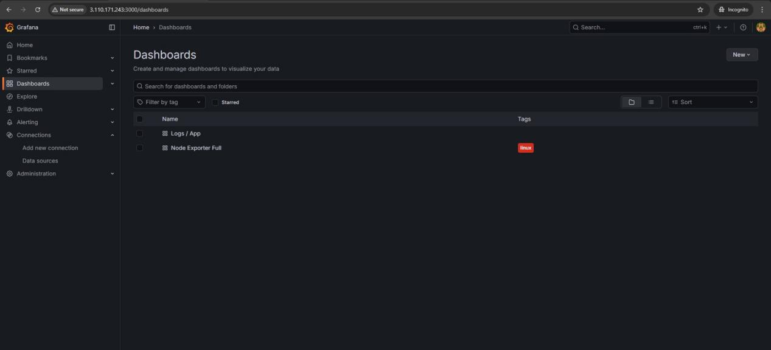

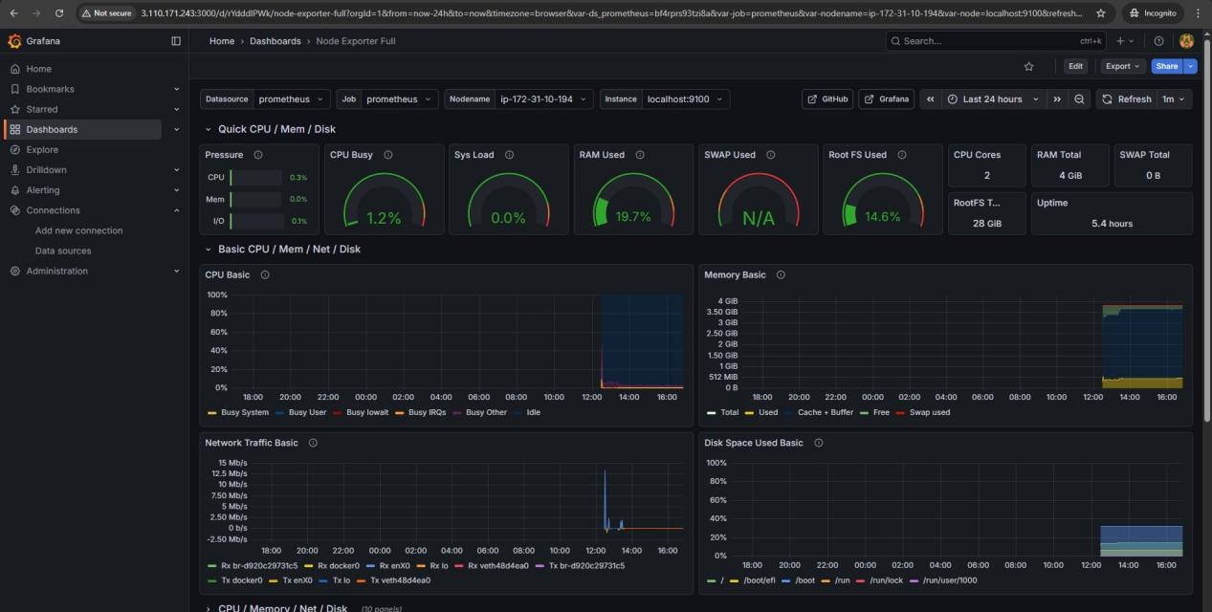

Monitoring the logs of server:

Installed Loki as docker container (for log collection):

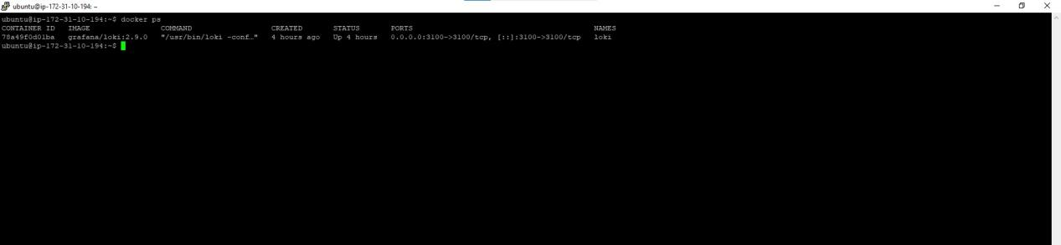

Installed Promtail (to send logs to Loki):

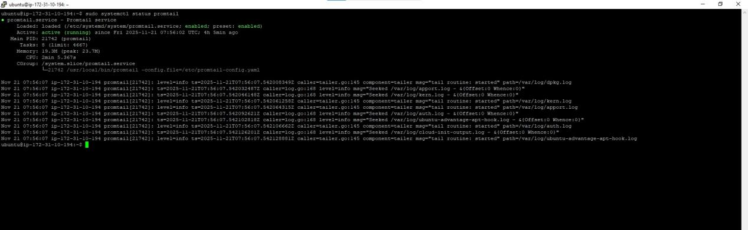

- In promotail config file add loki as client.

Add Loki as a Data Source in Grafana:

- Open Grafana and navigate to Configuration → Data Sources → Add data source.

- Select Loki from the list of available data sources.

- In the URL field, enter the Loki server address, e.g., http://<IP_ADDRESS>:3100.Click Save & Test to verify the connection.

Monitor the logs:

